Dashboard Design

Date | 18 September 2026
Team ID | MCA
Project Name | Smartphone Usage, Digital Addiction & Well-Being Analytics
Maximum Marks | 5 Marks

Creating an effective dashboard involves thoughtful design to ensure that the presented information is clear, relevant, and easily understandable for the intended audience. Here are some key principles and best practices for dashboard design

Layout & Visual Hierarchy
- Use Appropriate Visualizations: Choose the right chart type for your data. Use bar charts for comparisons, line charts for trends over time, and pie charts strictly for simple part-to-whole relationships.

- Colour and Theming: Utilize a limited, intentional color palette. Use high-contrast colors to draw attention to critical alerts, and keep background tones muted to reduce eye strain.

- Custom Visuals and Icons: Embed functional icons and tailored graphics to serve as visual anchors, making structural elements instantly recognizable.

- Use of Infographics: Simplify complex system workflows or qualitative data structures by integrating clean, illustrative graphic representations.

Interactivity & Functionality
- Interactive Filters and Slicers: Provide global and visual-level filters (like date ranges or category dropdowns) so users can customize the data view to their specific needs.

- Drill-Down Capabilities: Allow users to click into a high-level visual element to reveal deeper, granular layers of underlying data.

- Progressive Disclosure: Keep the main screen clean by hiding advanced configuration settings or secondary charts until the user intentionally requests them.

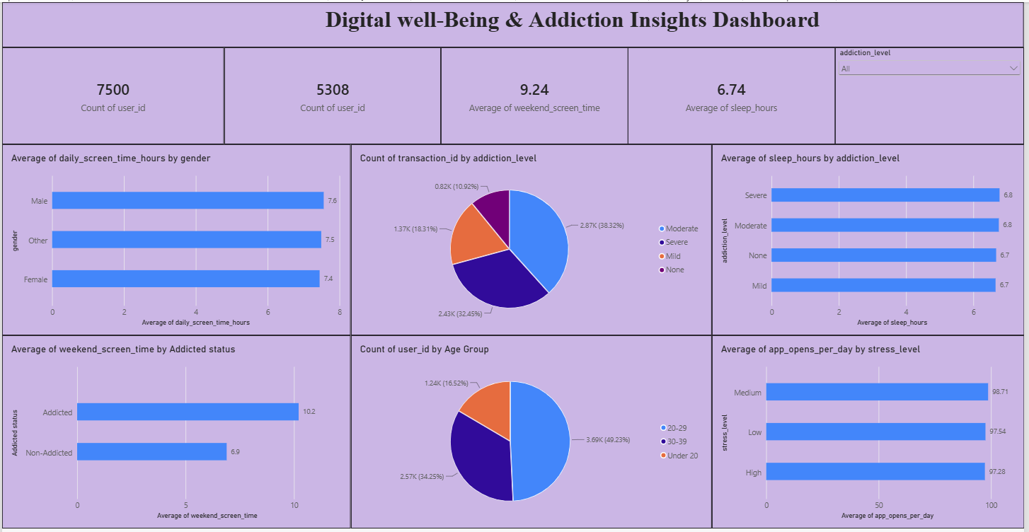

Key Dashboard Outcomes & Findings
- Total User Volume Matrix: The platform records a total metric footprint containing 7,500 data points for user entries alongside 5,308 distinct user IDs, representing a robust base size for cross-sectional analysis.

- Aggregated Screen Time and Sleep Metrics: The system shows a collective average weekend screen time of 9.24 hours, which presents a sharp contrast against a baseline average sleep duration of 6.74 hours across the tracked cohort.

- Gender-Based Screen Usage Trends: Daily screen time remains closely balanced across all demographic segments, with males averaging 7.5 hours, other categories averaging 7.5 hours, and females tracking slightly lower at 7.4 hours per day.

- Addiction Level Distribution: The global categorical breakdown shows that a Moderate level represents the largest sector at 38.32% (2.87K), followed closely by Severe levels at 32.45% (2.43K), Mild cases at 18.31% (1.37K), and those showing None at 10.92% (0.82K).

- Sleep Duration Deprivation Dynamics: Sleep schedules compress heavily as behavioral dependence climbs; individuals categorized under Severe and Moderate addiction levels share the lowest averages at 6.6 hours of sleep, whereas non-addicted cohorts reach a higher baseline of 6.7 sleep hours.

- Weekend Extrabound Usage Patterns: Behavioral addiction strongly skews weekend relaxation time, with individuals flagged as Addicted displaying a high average of 10.2 screen hours, compared to Non-Addicted peers who average 8.9 screen hours.

- Age Cohort Dominance: The primary age bracket engaging with these digital patterns belongs to the 20–29 demographic group, capturing a massive 49.23% (3.69K) of the platform profile base. The remaining footprint scales to the 30–39 group at 34.25% (2.57K) and the Under 20 group at 16.52% (1.24K).

- Stress Level App Activation Frequency: The daily operational app load remains high across all internal anxiety brackets, displaying a tight threshold where Medium stress triggers an average of 98.71 app opens, Low stress causes 97.54 opens, and High stress logs 97.28 daily app opens.

